Exercise III:



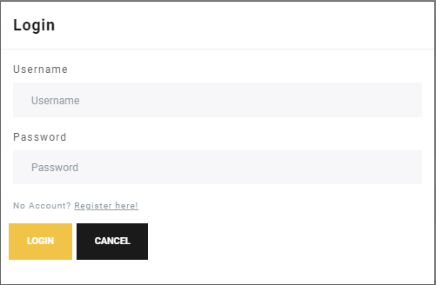

Login-Modal: Opened by clicking the Login Button in the Header.

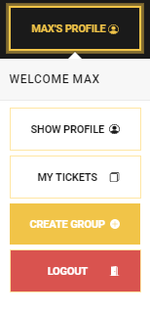

Profile Management-Popover: “SHOW PROFILE” and “MY TICKETS” not implemented, because of the dropping out of two team members. “CREATE GROUP” opens the Create-Group Use case. (Described later)

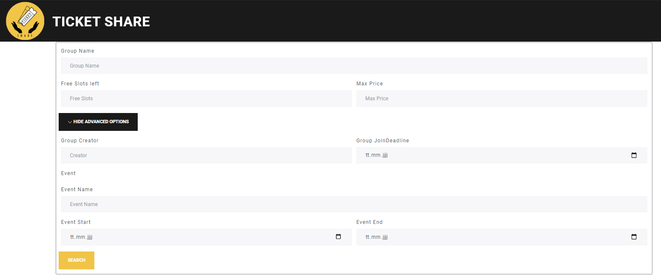

Search-Use case: The User can filter all available Groups by above shown criteria. Criteria’s can be freely combined. All text searches are “like” comparisons. The Creator Field can contain either the first name or the surname, or both separated by a space.

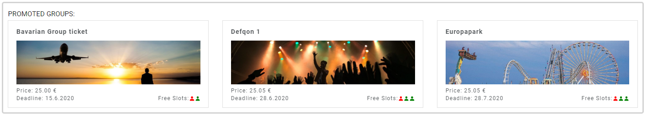

Promoted Groups: Presented in the BMC and VPC to generate revenue. A creator or an Event Manager can pay our webpage to promote respective groups.

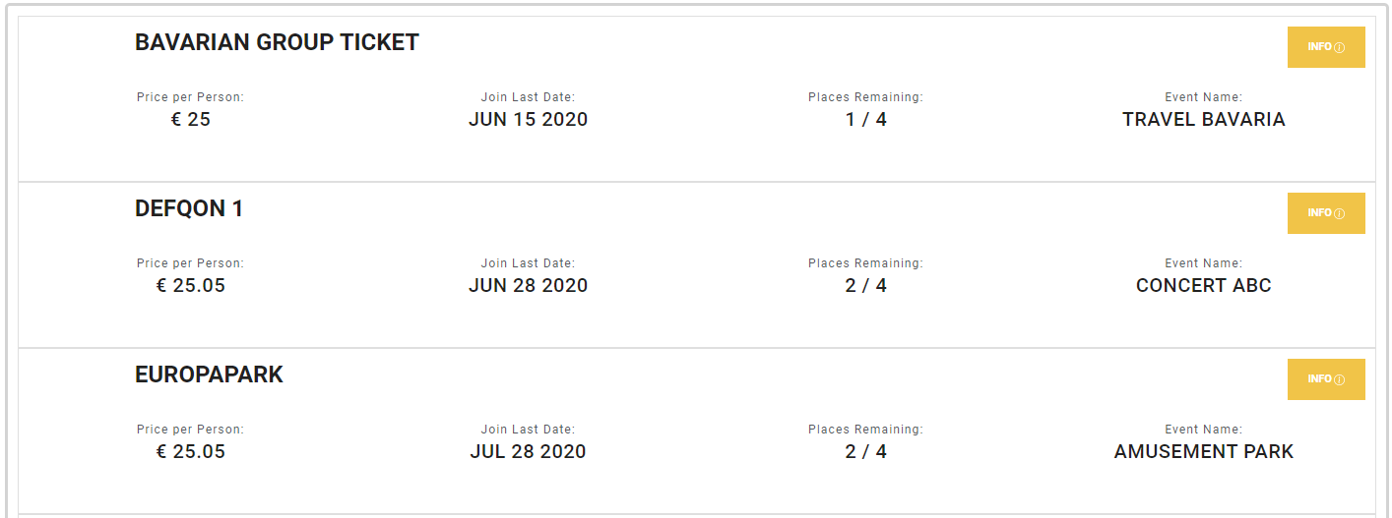

List View: Part of the Search-Use case. Contains all found groups for given filter. More information is shown when Info-Button is pressed.

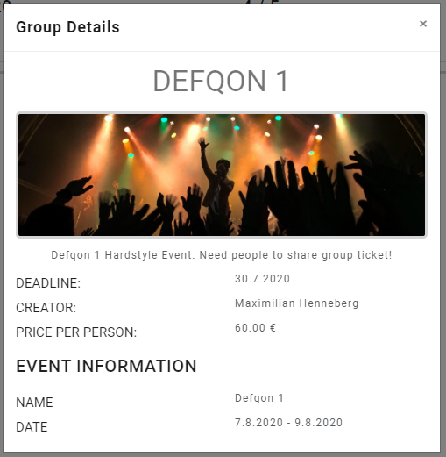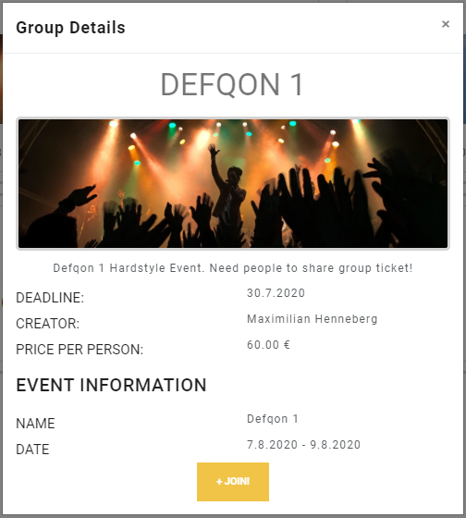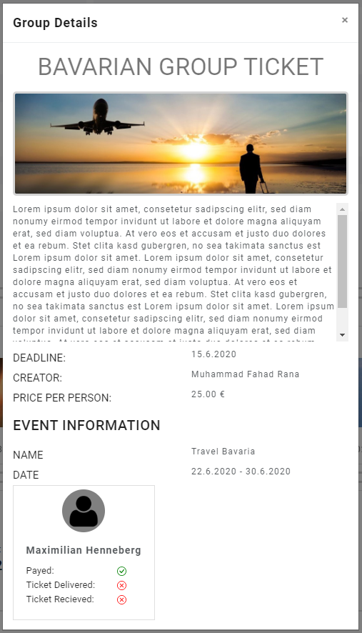

Group Detail Modal: Shown when Info-Button is pressed. From left to right the screenshot show cases for a: Not LoggedIn-User, A LoggedIn-User who has not yet joined the Group, and A LoggedIn-User who joined the Group.

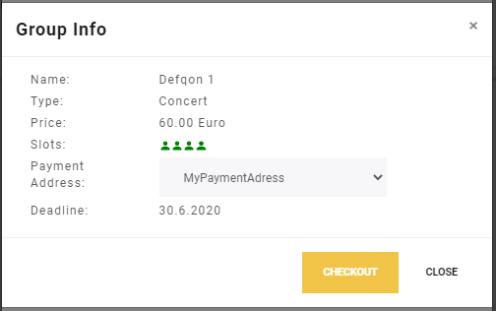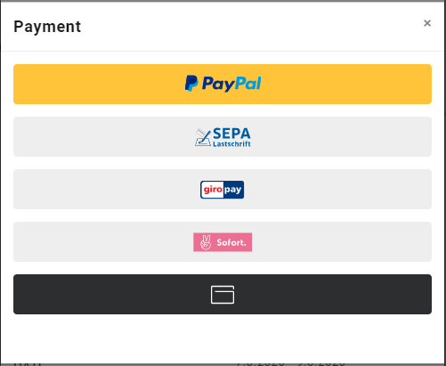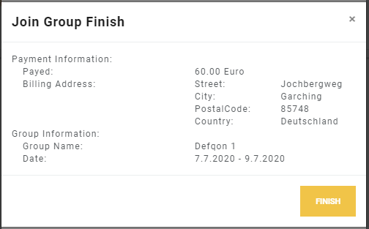

Join-Use case: From left to right the Join-Use case consists of: A short recap of the Group Information and a Dropdown to select a users Payment Address, A selection of supported Payment Methods (all provided by PayPal), A finished summary of the finished transaction. 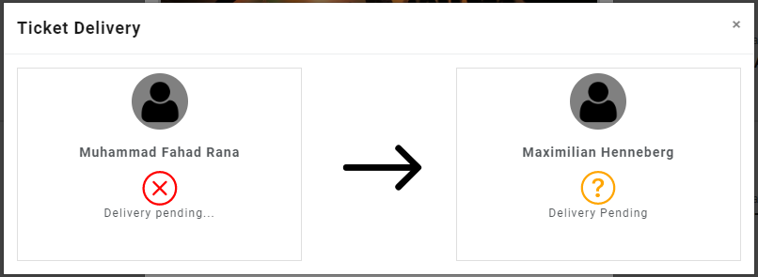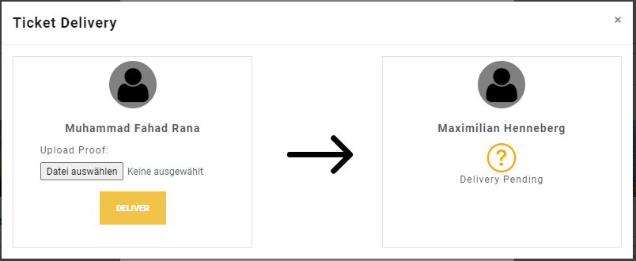

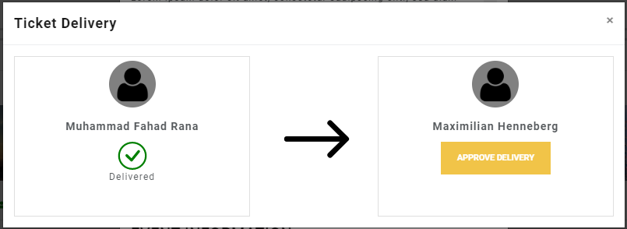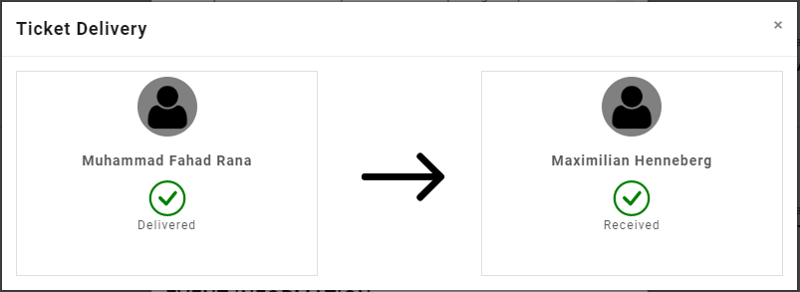

Ticket Deliver-Use case: From left to right:

* A joined user checking the status of his joined Group
* A creator of a Group checking the status of a joined User (able to deliver a Ticket including proof)
* A joined user checking the status of a joined Group (after a Ticket got delivered)
* View for a joined user or creator after the Ticket Delivery is done.

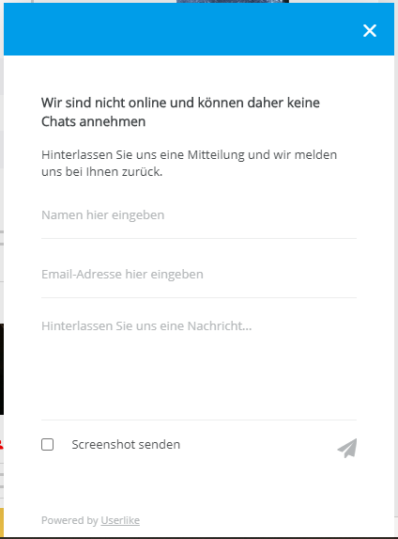

Support Chat: Integrated Button von Userlike. Proviedes the possibility to send a message to the website owner or even do live chat with one of our support members.

## USE CASE: Create Group

The user clicks on Create Group Button which takes us to the create group Page

The user then enters data and submits the form.

The errors are shown if there is a problem in the form:

The group can be shared if it is successfully created with the share buttons:

The group Component. The user can see detailed info and join it:

